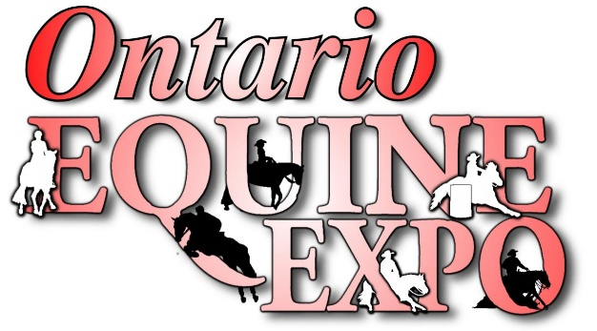
2026 Sponsorship
Dear Potential Sponsor,
Ontario Equine Expo is an event in Markham March 2026. We are looking to not only create a fantastic experience for our vendors and spectators but for our sponsors as well. This show will be held once a year in the spring. Our goal is for the Expo to be as much a learning tool, entertainment, and shopping experience as it is a social gathering. When an attendee comes through the doors of Ontario Equine Expo, they feel they are among friends. This type of event is one that many people look forward to from one year to the next, and for many of those people, it is almost like a family reunion, where they can meet up with friends they only see once or twice a year.
By you being a part of the Ontario Equine Expo, as a sponsor, you will demonstrate to our Customers and yours, that their interests are of utmost importance to your company. Every attendee Will understand that you support them by helping to create an Expo they can return to, year after year.
Your sponsorship, will allow us to do more with the Expo, introduce new ideas, and improve the Experience for everyone who attends in one way or another. This sponsorship package is intended to be a guide for some of the ways you can participate In making this event a tremendous success for everyone. We are very happy to discuss any options You may have, or to work with you to create a special package just for your company.
Thank you for considering us for some of your sponsorship budget!
Warm Regards,
Ryan Kent
Ryan Kent
Executive Director
Ontario Equine Expo
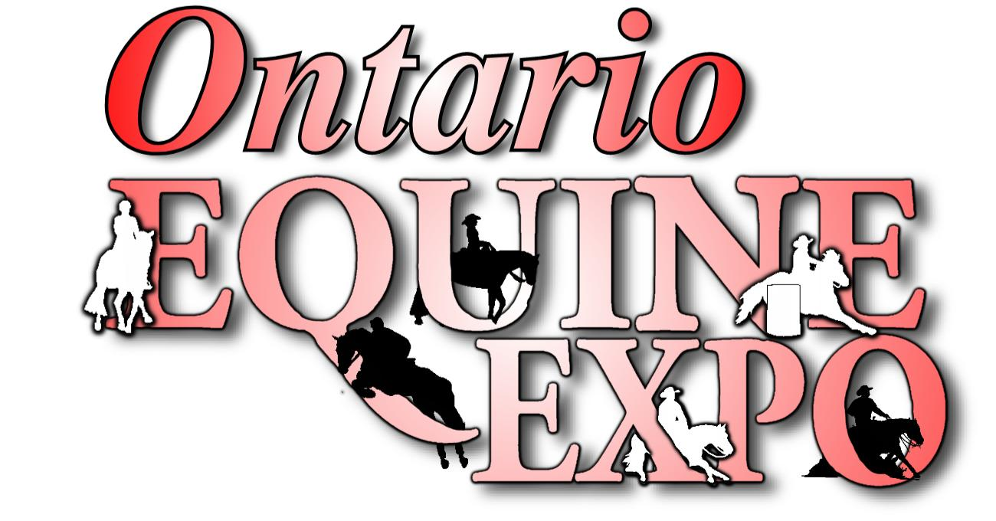
Title Sponsor
$10,000
Name and/or logo of Title Sponsor to appear in all Ontario Equine Expo marketing Material: Your package includes:
• Expo to be titled Ontario Equine Expo Presented by: Your Company
• Your logo in print material where Ontario Equine Expo logo is displayed
• Your logo in digital material where Ontario Equine Expo Logo is displayed
• Your supplied Banners Prominently Displayed, in prime locations during the show
• website Recognition – Your logo, on the Sponsors Banner on the Ontario Equine Expo website with a link to your site
• Clinic or Seminar Scheduled sessions during the weekend, promoting your Business products and/or services
•10x20 Booth Space and size at an agreed upon prime location within the Ontario Equine Expo Show
• Ontario Equine Expo Program – large ad in the Expo Program.
• Ontario Equine Expo Program – Cover recognition in the Expo Program.
• Social Media Recognition (agreed on promotional material, supplied by sponsor)
• Press Release Recognition with any podcast or radio adds we put on.
• 8 Ontario Equine Expo Weekend Passes
• 4 ontario Equine Expo VIP Passes( to Friday and Saturday evening performances)

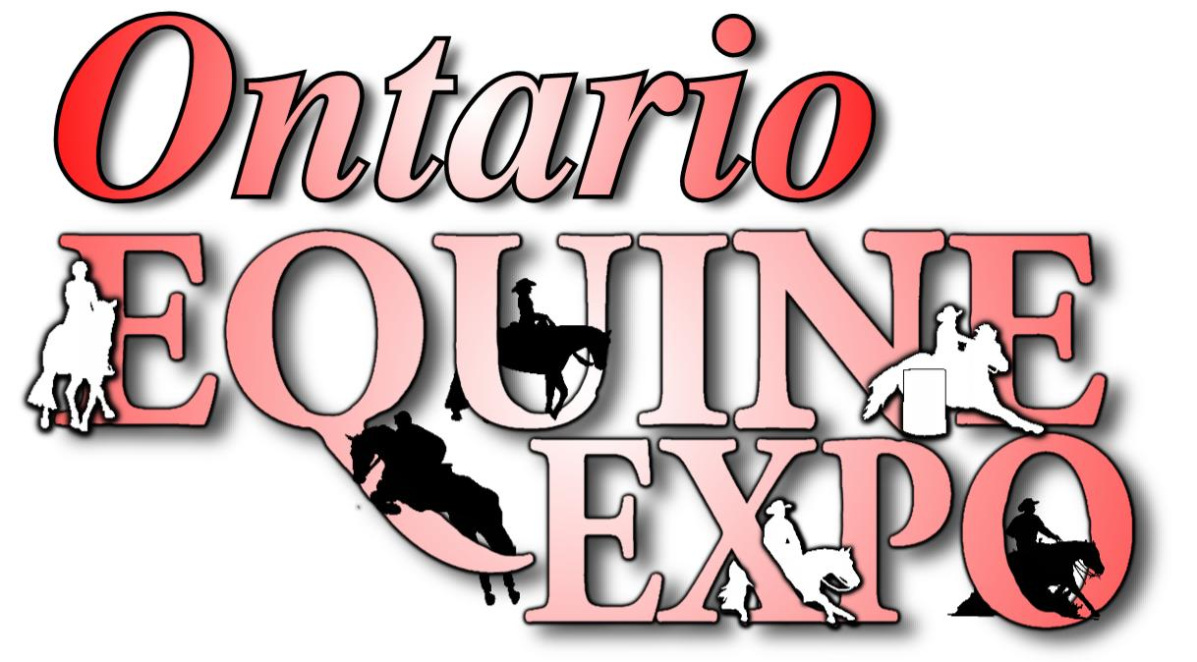
Arena sponsor
$5,000

The Arena will be titled with ‘your company’s name or product’. Your arena will be where the Saturday night performance, Clinics, demonstrations and events are conducted throughout the three (3) days of the Ontario Equine Expo show. Your package includes:
• Website Recognition – Your logo, on the Sponsors Banner on the Ontario Equine Expo website with a link To your site
• 25% off exhibitor space
• Social Media Recognition (agreed on promotional material, supplied by sponsor)
• Your provided signage and banners will be displayed in / around the Arena
• Announcements throughout the day promoting your name and the programs taking place in the arena
- Medium Logo on the program
• Medium logo on media wall
• 4 Ontario Equine Expo Weekend Passes
- 2 VIP for Friday or Saturday evening Show passes

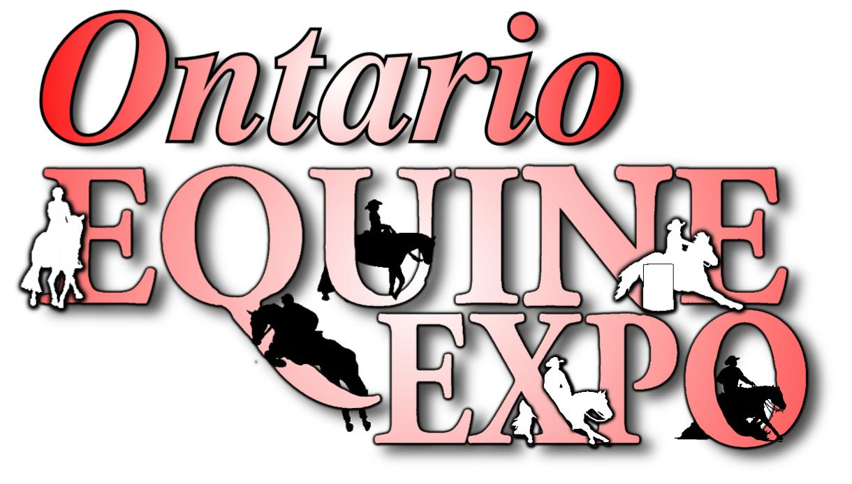
Trade Show Floor Sponsor
$2500 ( 2 per room available)

The Trade Show Floor (Pavilion) will be titled as ‘your company’s name or product’ building/pavilion. Your Package includes:
• Website Recognition – Your logo, on the Sponsors Banner on the Ontario Equine Expo website with a link To your site
• 10% off exhibitor space
• Social Media Recognition (agreed on promotional material, supplied by sponsor)
• Your provided banners will be displayed at the main entrances to the sponsored floor
• Medium logo on program
• Medium logo on media wall
• 2 Ontario Equine Expo Weekend Passes
- 2 VIP Friday or Saturday Evening Show passes

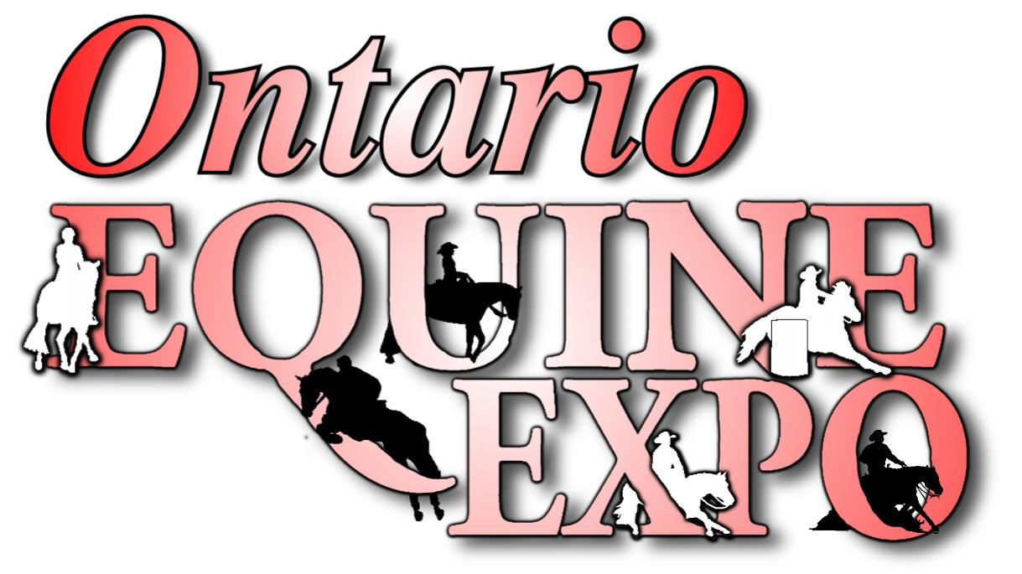

Chatterbox Saloon Sponsor
$1,000 (2 available)
The Chatterbox Saloon will be titled with ‘your company’s name or product’. Your area will be where the Presentations and talks are conducted throughout the three (3) days of Ontario Equine Expo show. Your package includes:
• Website Recognition – Your logo, on the Sponsors Banner on the Ontario Equine Expo website with a link to your site
• Social Media Recognition (agreed on promotional material, supplied by sponsor)
• Your provided signage and banners will be displayed in/around the Chatterbox Saloon
• Announcements throughout the day promoting your name and the programs taking place in the Saloon.
• small logo on program
• Medium logo on media wall
• 2 Ontario Equine Expo Weekend Passes

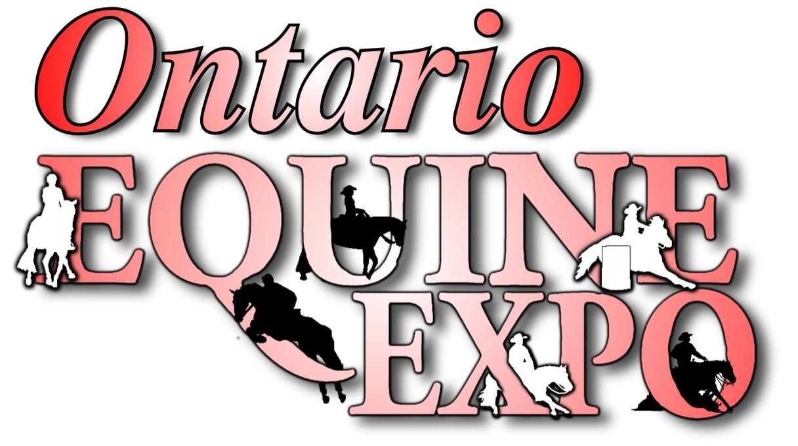

Clinician / Presenter Sponsor ( cost of clinician)
Your chosen clinician or presenter from our list will be presented by Your Company. Your Company will be listed in the
Schedule (printed and online) with the clinician or presenter. Your package includes:
• Website Recognition – Your logo on the Ontario Equine Expo website (clinician page) with a link to Your site
• Social Media Recognition (agreed on promotional material, supplied by sponsor)
- 1 post before the expo
• Announcements throughout the event promoting your name when the clinician/presenter is Announced
• Ontario Equine Expo Program – Logo printed with clinician information.
- 2 free weekend Expo passes

Friend of the Expo Sponsorship - $100 -$400
As a Friend of the Expo, your name/ logo/brand will be featured on the Friends of the Expo banner, displayed Prominently at the expo. Your package includes:
• Website Recognition – Your logo, on the Ontario Equine Expo website with a link to your site
• name / logo in the list of sponsors in the Ontario Equine Expo Program
- 1 free day pass over $200 / or 2 free one day passes for $400

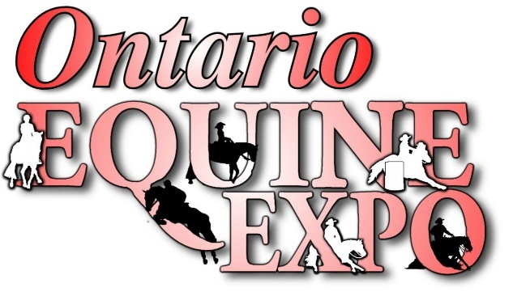
Bull Riding Sponsorship
Gold - $5,000 2 available
The show will be titled with ‘your company’s name. The bull riding will be saturday night. The even will be in the 2 sponsors names and will be announce through the event and all posts about the bull riding.
Your package includes:
• Website Recognition – Your logo, on the Sponsors Banner on the Ontario Equine Expo website with a link To your site
• 75% off exhibitor space up to 10x20)
• Social Media Recognition (agreed on promotional material, supplied by sponsor)
• Your provided signage and banners will be displayed in / around the Arena
• Announcements throughout the day promoting your name and the event.
- Medium Logo on the program
• Medium logo on the sponsorship album on Facebook
• 4 Ontario Equine Expo Weekend Passes
- 4 VIP Friday or Saturday evening Show passes

Silver - $2,500 ( 4 available)
Social Media Recognition (agreed on promotional material, supplied by sponsor)
• Your provided signage and banners will be displayed in / around the Arena
- 25% off vendor space up to 10x20 booth.
• Announcements throughout the day promoting your name and the event.
- Medium Logo on the program
• Medium logo on the sponsorship album on Facebook
• 2 Ontario Equine Expo Weekend Passes
- 2 VIP Friday or Saturday evening Show passes

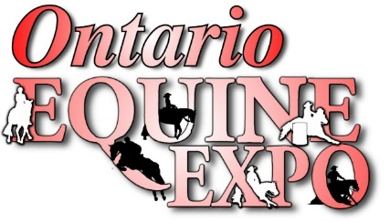

Chute Sponsor - $1000 x 4
- One chute door will have your banner on it.
- Announced during the bull ride as a chute Sponsor
- 2 tickets to the evening show Saturday night
- 2 Day passes

Demo Ring or warmup ring Sponsor - $1800 ( 2 available)

- The ring will be called your company name ( ie Jim Bob’s demonstration ring or demonstration ring presented by Jim bob’s)
- 2 free weekend passes
- Social media posts
- Link on the website to your page
- Name / logo on programs with demo ring schedule

Contact us at ontarioequineexpo_acc@outlook.com for inquiries and for invoicing for sponsorships. E Transfers can go to this email and cheques are payable to Ontario Equine Expo.
Office 226-700-1752 / Miranda Kent 226-228-6875

Buckle Sponsorship( 10 buckles available)
- 2 Free Day passes
- Logo on the website
- Announced that you are the buckle sponsor for the events.
- 2 Social media posts
- Photo of the winner with their buckle

